Graph-Based Transaction Fraud: End-to-End Ingestion and Quality Controls
Prepared by: Nishikanta Sahu
Date: Feb 17, 2026
Version: 1.0

Executive Summary
This solution ingests transactional data into Neo4j through two complementary paths:
- Batch processing (AWS Glue → Neo4j) for bulk historical or periodic loads. Records are standardized and validated; any rows that fail type/schema rules are written to a dedicated “bad data” S3 area, partitioned by date. Source is tagged as batch in Neo4j.
- Streaming processing (Confluent Cloud Kafka → Neo4j) for near-real-time events. The consumer validates payload shape and timestamps, performs idempotent upserts, and routes any rejects to a separate “bad data” S3 area under source=kafka. Source is tagged as kafka in Neo4j.
To maintain strong data hygiene and auditability, the design includes:
- Bad-record isolation for both pipelines, written to S3 with clear partitioning and rich error context. Results land in: Central location: s3://graph-based-transaction-fraud/fraud/bad-transactions/,(kafka or batch) /partitioned by date.
- Automated daily reconciliation (AWS Lambda + EventBridge) that summarizes counts by source, duplicates, field mismatches, streaming lag, and an overall reconciliation summary. Results land in:
s3://neo4j-reconciliation-daily/reconciliation/ (partitioned by date).

End-to-End Architecture Overview
The platform uses a hybrid ingestion model: Batch for historical/periodic files and Real‑time for live streaming events. Neo4j serves as the unified analytical store enabling graph‑based fraud pattern detection.

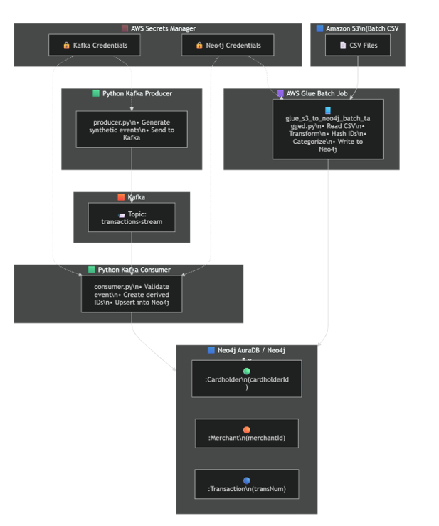

  - Key Components
- AWS Glue Batch Job standardizes and validates heterogeneous files (CSV/JSON/JSONL), casts types, detects mismatches, parses timestamps safely, and writes clean rows to Neo4j. Bad rows are written to S3, partitioned by date.
- Kafka Producer (utility) generates synthetic transactions to Confluent Cloud with SASL/SSL auth from AWS Secrets Manager.
- Kafka Consumer validates events, performs idempotent merges into Neo4j, and routes any invalid/failed record to S3 with diagnostics.
- Daily Reconciliation via EventBridge (scheduled) → Lambda job that computes:
counts by source, duplicates, field mismatches, stream ingestion lag, and a summary; results published to s3://neo4j-reconciliation-daily/reconciliation/ (by date).

Data Flow Details

  - Batch Ingestion Path (S3 → Glue → Neo4j)
- Input Formats & Standardization
The Glue job ingests CSV, JSONL, pretty JSON, even when column order varies across files. It reads per-file (for CSV) and unions by column name to avoid positional misalignment. Headers are trimmed, and unified aliases map different source headers to canonical names.

- Type Casting & Mismatch Detection
Numeric fields (amt, lat/long, city_pop, is_fraud) are cast explicit. Any non-empty value that fails casting is flagged. The job records exactly which fields caused rejection (mismatch_cols) for each bad row.

- Timestamp Parsing (Resilient)
A guarded UDF tries a list of known patterns; impossible or malformed timestamps yield null instead of crashing the task. Rows with unparseable timestamps (or missing keys like trans_num/amount) are redirected to bad-records S3, partitioned by ingest_date.

- Neo4j Write
The job builds a strict payload and uses the Neo4j Spark Connector to MERGE Transaction nodes with source='batch'. Writes are repartitioned to limit concurrent transactions and reduce deadlocks; connector options include batch size and retry policies. Optional verification can log counts post-write.

- Bad Data Handling (Batch)
Rejected rows (casts, timestamp parse failures, or missing keys) are written to:
s3://graph-based-transaction-fraud/fraud/bad-transactions/
partitioned by date (and distinguishable as batch).

- Glue Job configuration (IAM role, DPUs)

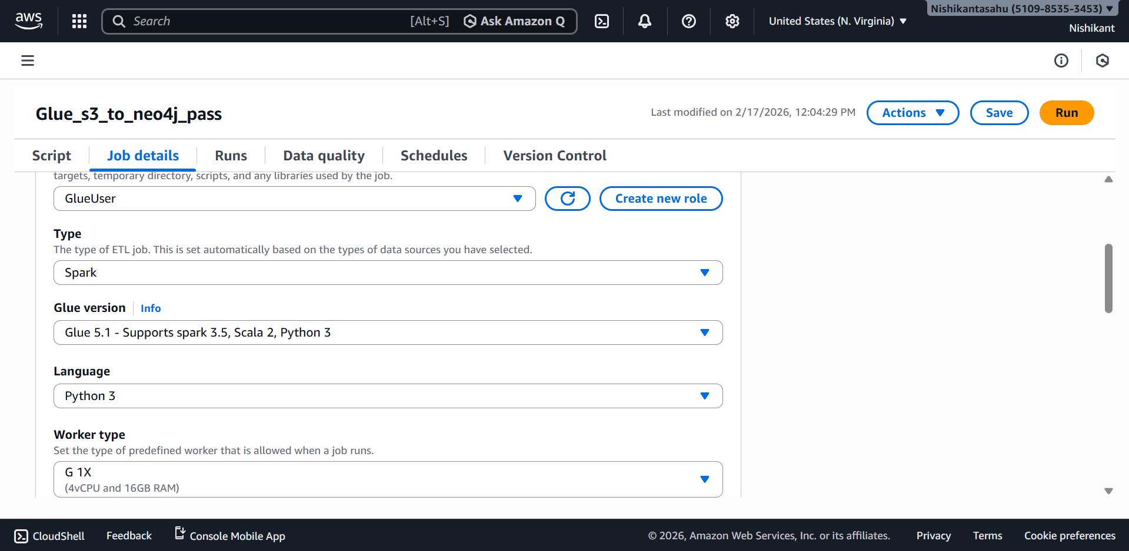

- Gluejob
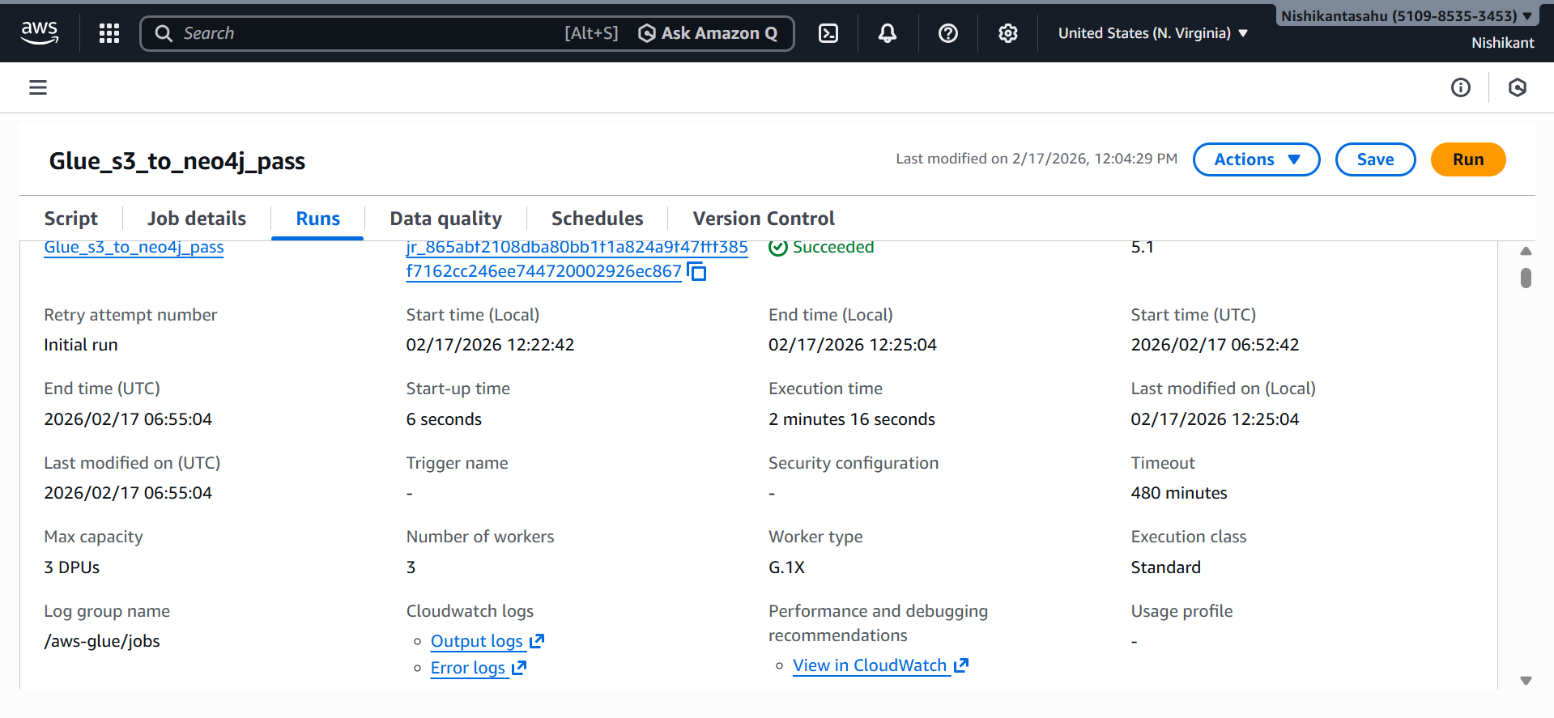
- S3 “bad-transactions” layout (source=batch / ingest_date=YYYY-MM-DD)

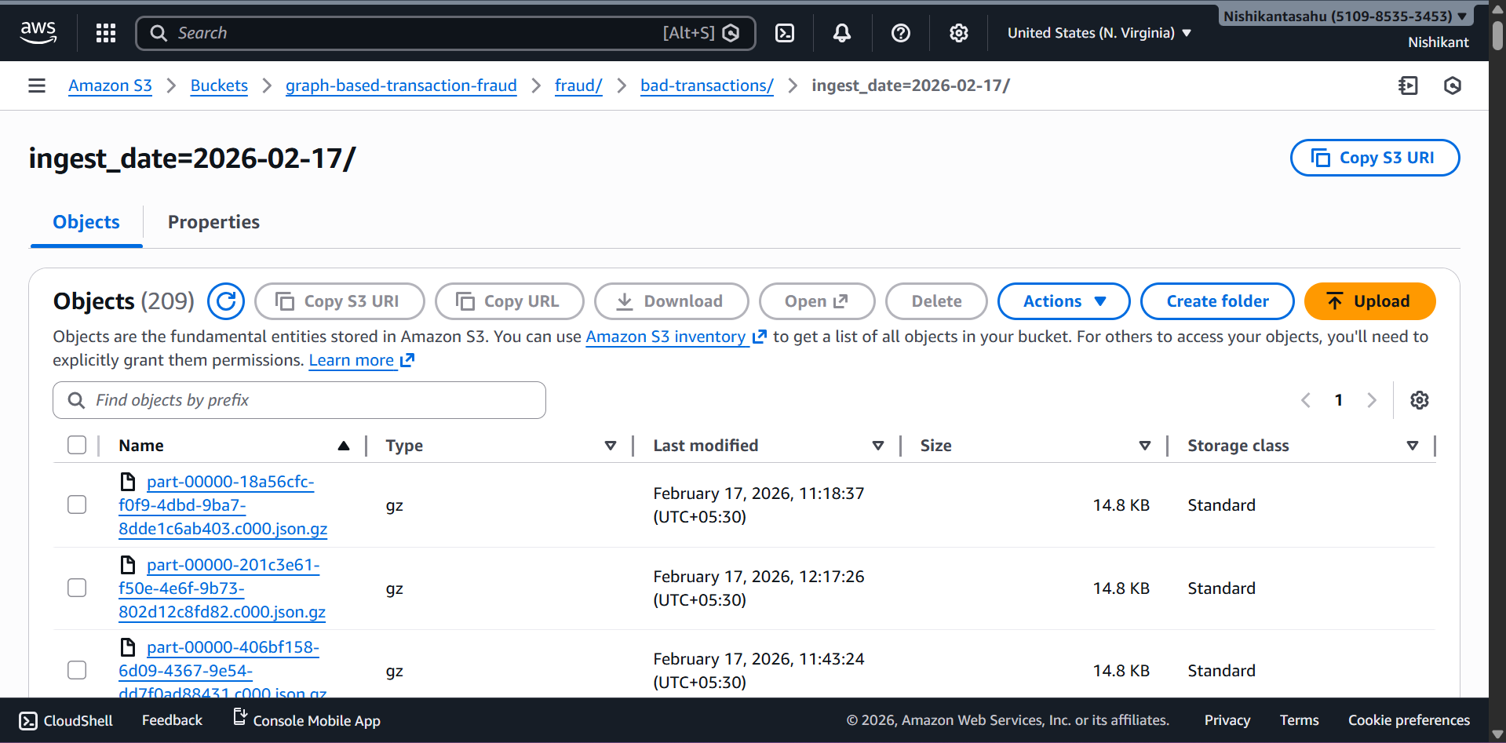

- Neo4j : sample Transaction node with source="batch"

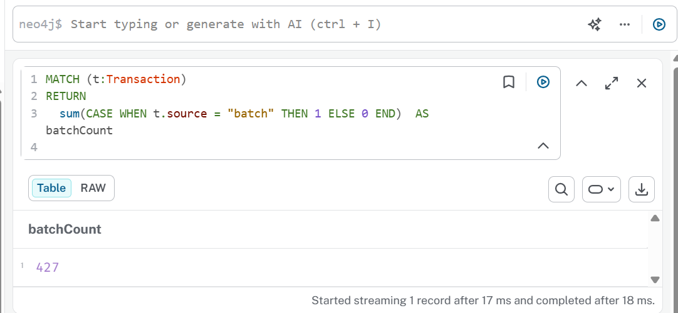

Real‑time Pipeline (Kafka → Python Consumer → Neo4j)

- Production
The producer.py script loads non-secret config from .env, fetches Kafka SASL credentials from AWS Secrets Manager, and publishes synthetic transactions to the target topic. Delivery outcomes are logged.

- Consumption & Validation
The consumer.py reads from Confluent Cloud using SASL/SSL, validates messages with Pydantic (schema enforcement), checks timestamp format, and computes stable IDs (SHA-256) for Cardholder and Merchant entities before upserting. Any JSON decode errors, schema mismatches, invalid timestamps, or Neo4j write errors are routed to S3.

- Neo4j Upsert Strategy
The consumer uses idempotent MERGE for Cardholder, Merchant, and Transaction—ensuring safe replays and exactly-once semantics at the graph level. Transaction nodes carry source="kafka" and ingestedAt, with updatedAt set on matches.

- Bad Data Handling (Streaming)
Each rejected message is written as a gzipped JSON envelope to S3, keyed by source=kafka/ingest_date=YYYY-MM-DD/p{partition}-o{offset}.json.gz. The envelope includes raw payload, error type/detail, failed fields, and Kafka metadata for pinpoint replay and audit. Target root aligns with your provided location.

- Confluent Cloud Topic

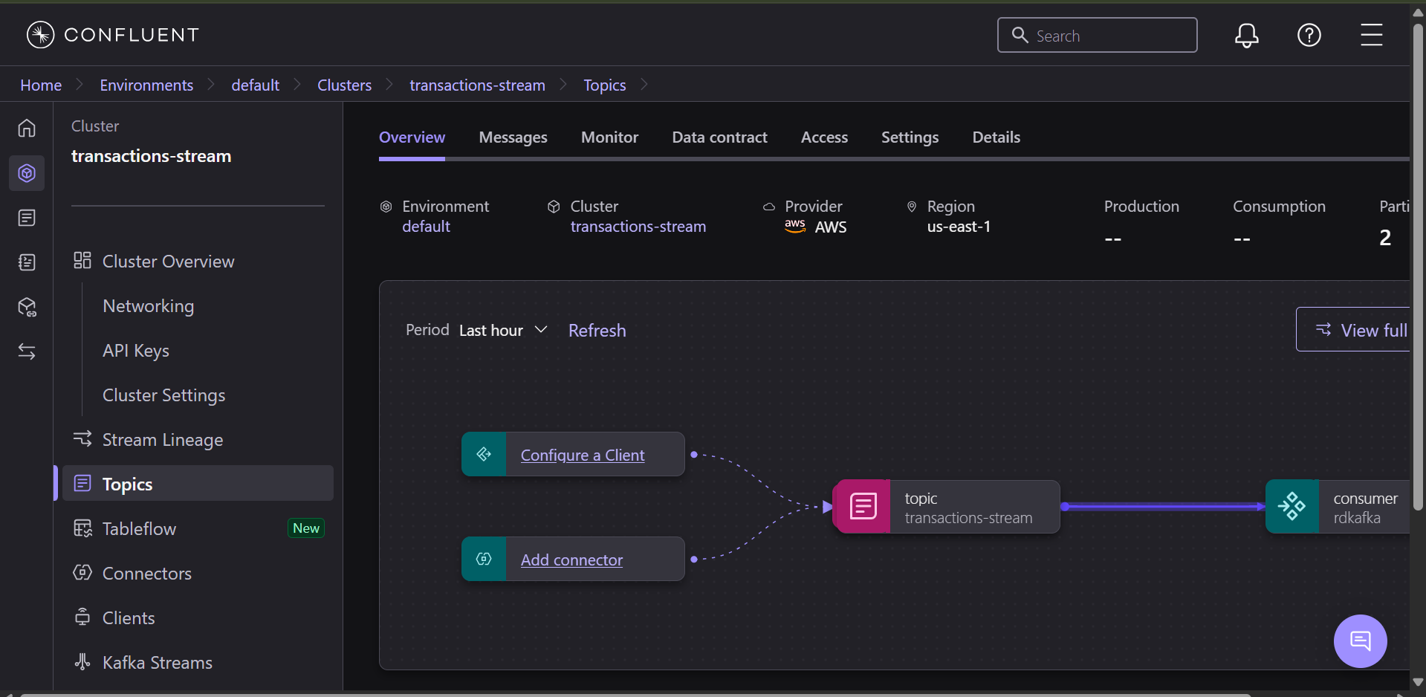

- Python Producer & Consumer CLI run (terminal)

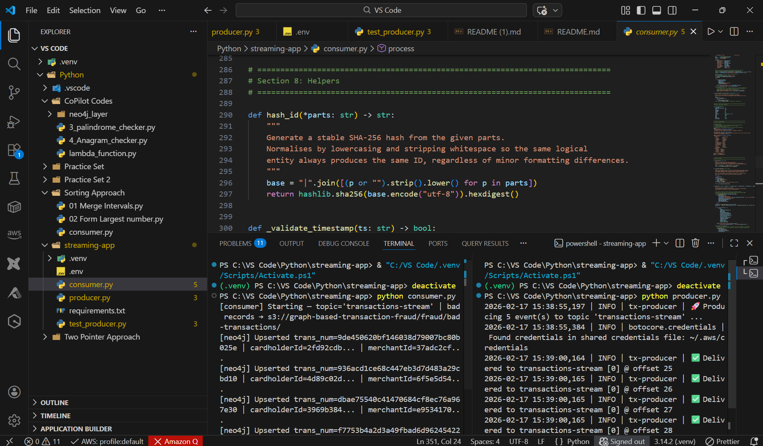

- S3 “bad-transactions” layout (source=kafka)

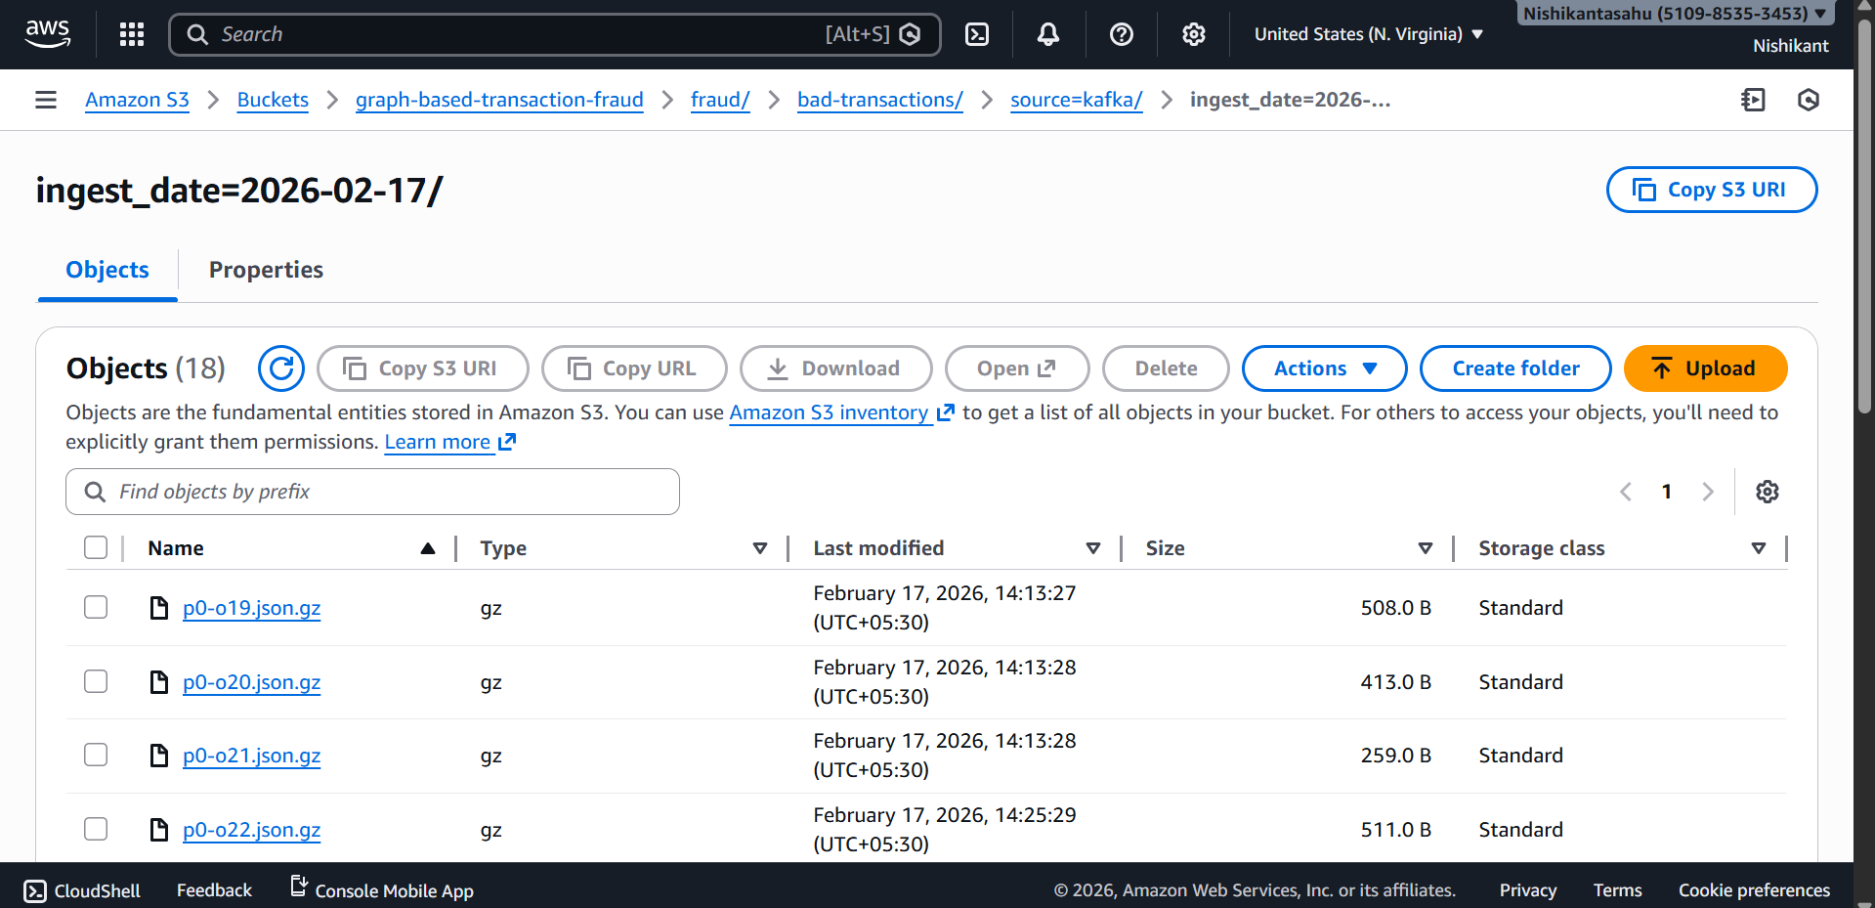

- Neo4j : sample Transaction node with source="batch"
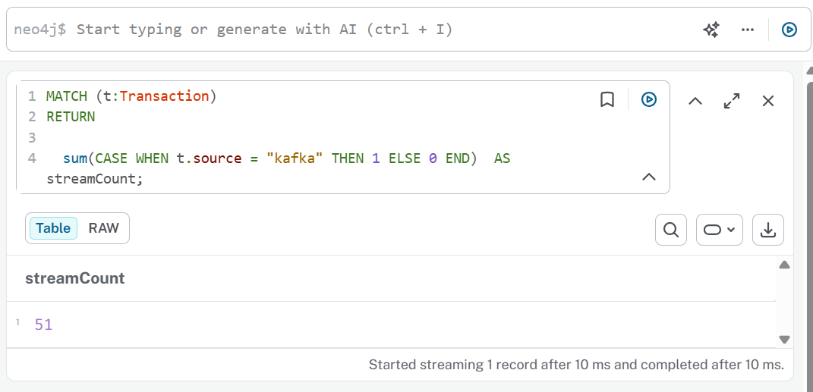

Graph Data Model

- Nodes
- Transaction
- Keys/Indexes: transNum (unique identifier)
- Attributes: ts, amount, isFraud, category/channel (stream), city, state, lat/long variants, job (stream), file (batch), source (kafka|batch), ingestedAt, updatedAt.
- Cardholder
- Key: cardholderId (SHA-256 of DOB, city, state—no raw PII stored).
- Merchant
- Key: merchantId (SHA‑256 of rounded coordinates + city/state)

- Relationships
- (Cardholder)-[:PERFORMED]->(Transaction)
- (Transaction)-[:AT_MERCHANT]->(Merchant)
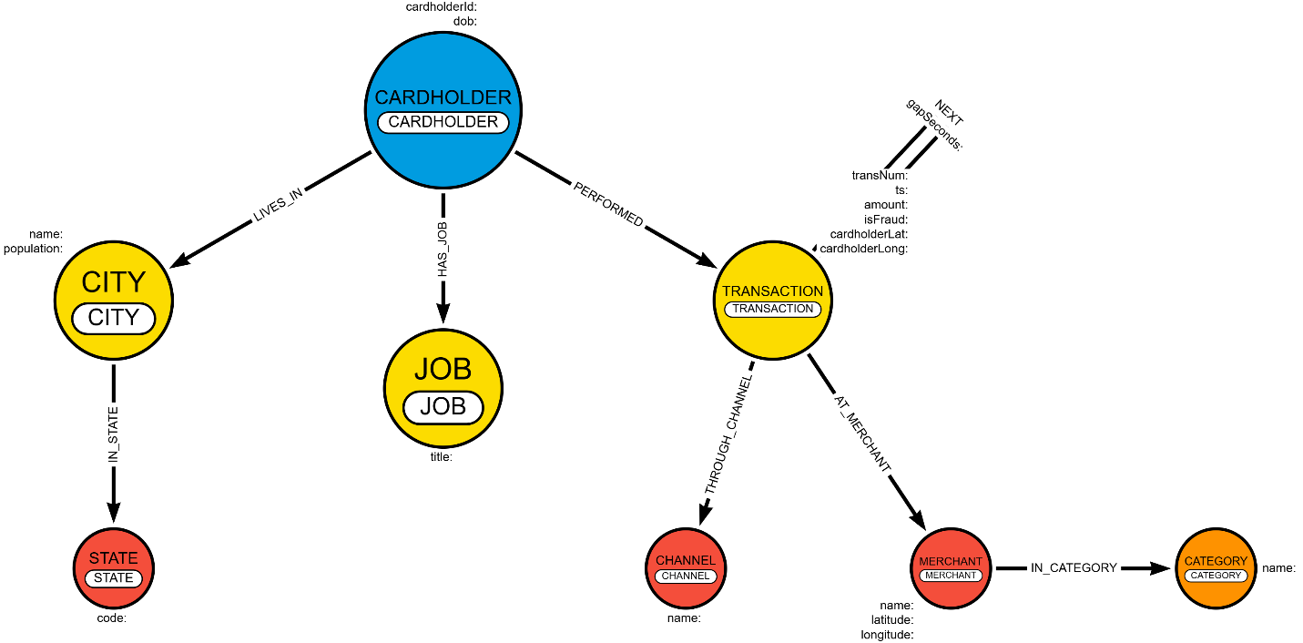

4.1 Source-to-Graph Mapping (Key Fields)
Sample Data Column | Meaning | Graph entity / property
trans_date_trans_time | Transaction timestamp (some rows: date-only; most rows: date+time) | Transaction.ts
Client Name | Cardholder name (PII) | Cardholder.name (store hashed/pseudonymized in prod)
transaction type | Channel + category-like label (grocery_pos, shopping_net, …) | Channel.name + optionally Category.name
amt | Amount | Transaction.amount
city, state | Cardholder city/state | City.name, State.code; (:Cardholder)-[:LIVES_IN]->(:City)-[:IN_STATE]->(:State)
lat, long | Cardholder geo (purchase location) | Transaction.cardholderLat, Transaction.cardholderLong
city_pop | City population | City.population
job | Cardholder job title | Job.title
dob | Cardholder date of birth | Cardholder.dob (or age derived)
trans_num | Transaction ID | Transaction.transNum (unique)
latitude, longitude | Merchant coordinates (naming differs from problem text) | Merchant.latitude, Merchant.longitude
merchant | Merchant name | Merchant.name (unique by normalized name)
category | Merchant category | Category.name
is_fraud | 0/1 | Transaction.isFraud (boolean/int)

4.2 Neo4j Constraints & Indexes
// Uniqueness constraints
CREATE CONSTRAINT cardholder_id_unique IF NOT EXISTS
FOR (c:Cardholder) REQUIRE c.cardholderId IS UNIQUE;
CREATE CONSTRAINT merchant_id_unique IF NOT EXISTS
FOR (m:Merchant) REQUIRE m.merchantId IS UNIQUE;
CREATE CONSTRAINT transaction_transNum_unique IF NOT EXISTS
FOR (t:Transaction) REQUIRE t.transNum IS UNIQUE;
// Helpful indexes
CREATE INDEX transaction_ts IF NOT EXISTS FOR (t:Transaction) ON (t.ts);
CREATE INDEX transaction_isFraud IF NOT EXISTS FOR (t:Transaction) ON (t.isFraud);

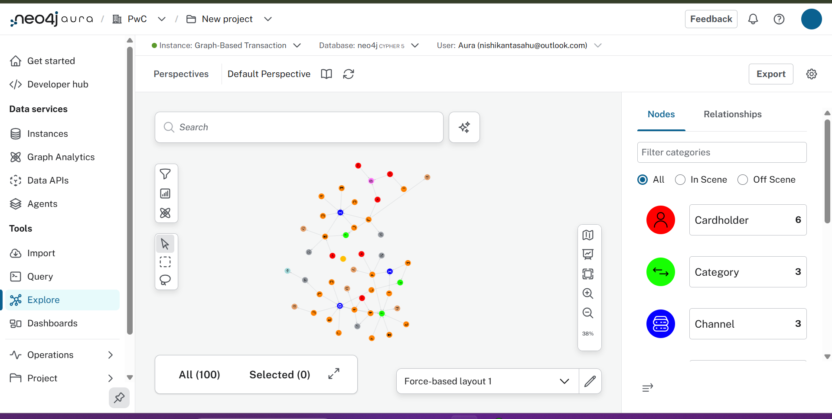

4.3 Fraud Pattern Queries:

- UseCase 1 : Detect transactions that deviate significantly from the customer’s normal spending patterns.
// 1) Anchor each transaction to score
MATCH (c:Cardholder)-[:PERFORMED]->(t:Transaction)-[:AT_MERCHANT]->(m:Merchant)
WITH c, t, m

// 2) Velocity signal: how many tx in the last 10 minutes by the same cardholder
OPTIONAL MATCH (c)-[:PERFORMED]->(tprev:Transaction)
WHERE tprev.ts <= t.ts AND tprev.ts > t.ts - duration({ minutes: 10 })

WITH c, t, m,
count(tprev) AS tx_last_10m,
toFloat(t.amount) AS amt,
t.category AS cat

// 3) Cardholder baseline (median & MAD). Require ≥ 5 transactions to trust it.
CALL (c) {
WITH c
MATCH (c)-[:PERFORMED]->(tx:Transaction)
WHERE tx.amount IS NOT NULL
// Median over rows

WITH c, percentileCont(toFloat(tx.amount), 0.5) AS med
// Collect values to compute absolute deviations from the median

MATCH (c)-[:PERFORMED]->(tx2:Transaction)
WHERE tx2.amount IS NOT NULL
WITH med, collect(toFloat(tx2.amount)) AS amts, count(tx2) AS n

WHERE n >= 5
WITH med, amts, n, [x IN amts | abs(x - med)] AS devs
UNWIND devs AS d
WITH med, percentileCont(d, 0.5) AS mad, n
RETURN med AS ch_med, mad AS ch_mad, n AS ch_n
}

WITH c, t, m, tx_last_10m, amt, cat, ch_med, ch_mad, coalesce(ch_n, 0) AS ch_n

// 4) Category baseline (median & MAD). Require ≥ 30 transactions in the category.
CALL (cat) {
WITH cat
MATCH (txc:Transaction)
WHERE txc.category = cat AND txc.amount IS NOT NULL
// Median over rows

WITH cat, percentileCont(toFloat(txc.amount), 0.5) AS med
// Collect values to compute absolute deviations from the median

MATCH (txc2:Transaction)
WHERE txc2.category = cat AND txc2.amount IS NOT NULL
WITH med, collect(toFloat(txc2.amount)) AS amts, count(txc2) AS n
WHERE n >= 30
WITH med, amts, n, [x IN amts | abs(x - med)] AS devs
UNWIND devs AS d
WITH med, percentileCont(d, 0.5) AS mad, n
RETURN med AS cat_med, mad AS cat_mad, n AS cat_n
}

WITH c, t, m, tx_last_10m, amt, cat, ch_med, ch_mad, ch_n, cat_med, cat_mad, coalesce(cat_n, 0) AS cat_n

// 5) Global baseline (median & MAD) as last resort
CALL () {
MATCH (txg:Transaction)
WHERE txg.amount IS NOT NULL
// Median over rows

WITH percentileCont(toFloat(txg.amount), 0.5) AS med
// Collect values to compute absolute deviations from the median

MATCH (txg2:Transaction)
WHERE txg2.amount IS NOT NULL
WITH med, collect(toFloat(txg2.amount)) AS amts
WITH med, [x IN amts | abs(x - med)] AS devs
UNWIND devs AS d
WITH med, percentileCont(d, 0.5) AS mad
RETURN med AS g_med, mad AS g_mad
}

// 6) Pick the best available baseline (cardholder > category > global)
WITH c, t, m, tx_last_10m, amt, cat, ch_med, ch_mad, ch_n, cat_med, cat_mad, cat_n, g_med, g_mad
WITH c, t, m, tx_last_10m, amt, cat,
CASE
WHEN ch_n >= 5 THEN ch_med
WHEN cat_n >= 30 THEN cat_med
ELSE g_med
END AS base_med,
CASE
WHEN ch_n >= 5 THEN ch_mad
WHEN cat_n >= 30 THEN cat_mad
ELSE g_mad
END AS raw_mad,
ch_n, cat_n

// 7) Stabilize MAD (floor) and compute anomaly score; also cap extreme scores.
WITH c, t, m, tx_last_10m, amt, cat, base_med, raw_mad, ch_n, cat_n
WITH c, t, m, tx_last_10m, amt, cat, base_med,
CASE
WHEN raw_mad IS NULL OR raw_mad = 0 THEN 1e-9
WHEN raw_mad < 0.25 THEN 0.25
ELSE raw_mad
END AS base_mad,
ch_n, cat_n
WITH c, t, m, tx_last_10m, amt, cat,
abs(amt - base_med) / base_mad AS raw_score,
CASE
WHEN ch_n >= 5 THEN 'cardholder'
WHEN cat_n >= 30 THEN 'category'
ELSE 'global'
END AS baseline_used
WITH c, t, m, tx_last_10m, amt, cat, baseline_used,
CASE WHEN raw_score > 25 THEN 25 ELSE raw_score END AS mad_score

// 8) Return results (add your own thresholding or persistence if needed)
RETURN
t.transNum AS trans_num,
toString(t.ts) AS ts,
c.cardholderId AS cardholder,
coalesce(m.name, m.merchantId) AS merchant,
cat AS category,
amt AS amount,
baseline_used,
round(mad_score, 2) AS amount_anomaly_score,
tx_last_10m,
round(0.7*mad_score + 0.3*toFloat(tx_last_10m), 2) AS combined_score
ORDER BY combined_score DESC, amount_anomaly_score DESC
LIMIT 100;

- UseCase 2 : Very small, repeated transactions in short bursts across multiple merchants.

MATCH (c:Cardholder)-[:PERFORMED]->(t1:Transaction)-[:AT_MERCHANT]->(m1:Merchant),
(c)-[:PERFORMED]->(t2:Transaction)-[:AT_MERCHANT]->(m2:Merchant)
WHERE t1 <> t2
AND t1.amount <= 5 AND t2.amount <= 5
AND m1.merchantId <> m2.merchantId
AND duration.inSeconds(t1.ts, t2.ts).seconds <= 10 * 60
WITH c, collect(distinct t1) + collect(distinct t2) AS txs
WITH c, apoc.coll.toSet(txs) AS uniqTx
WHERE size(uniqTx) >= 3
RETURN c.cardholderId AS cardholder,
[t IN uniqTx | t.transNum] AS suspiciousTransactions,
size(uniqTx) AS burstCount;

Automated Reconciliation (Daily)
- Scheduler: Amazon EventBridge triggers a Lambda once per day.
- Computation: The Lambda aggregates (from Neo4j and/or staging metrics) the daily record counts by source, duplicate detection, field mismatch counts, streaming ingestion lag, and a roll-up summary.
- Output: Results are written to s3://neo4j-reconciliation-daily/reconciliation/, partitioned by date (e.g., dt=YYYY-MM-DD).
- Usage: This provides an immutable, time-series trail of completeness and quality, enabling quick investigations (what changed, when, and why).

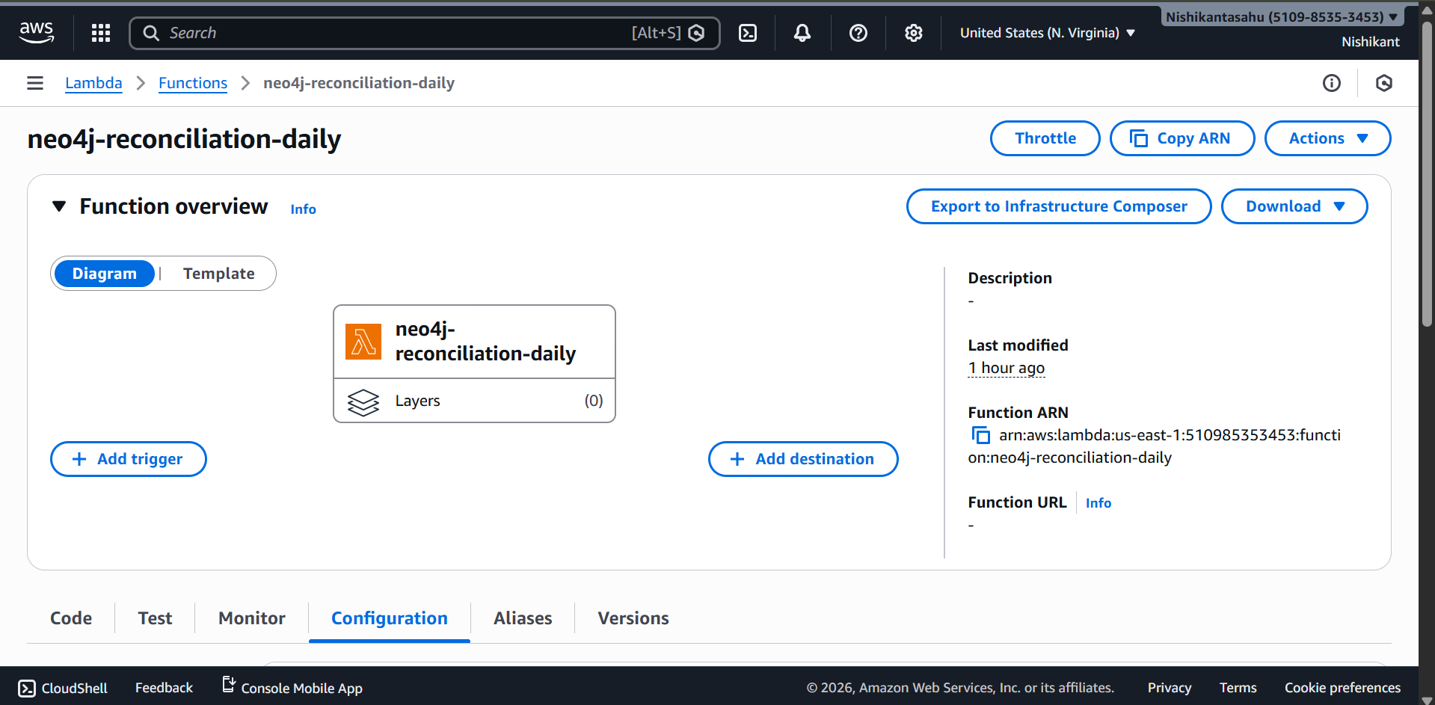
- Reconciliation Bucket:

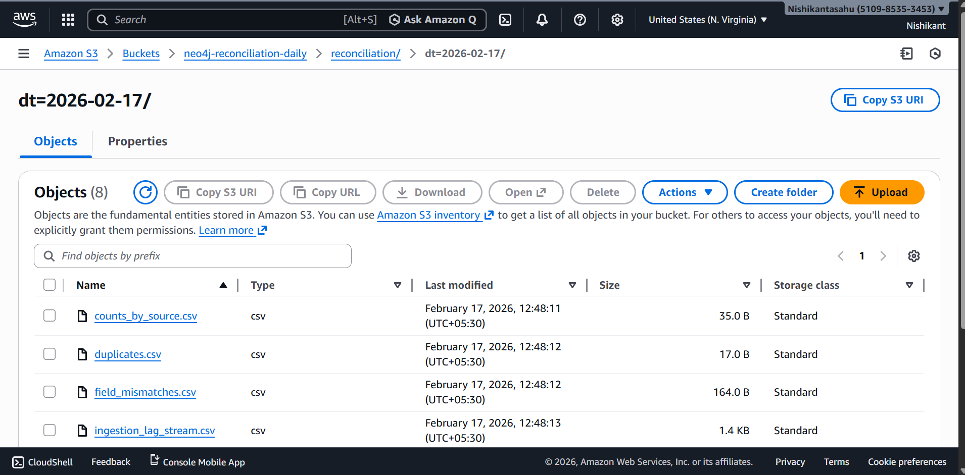

Configuration & Secrets
- Secrets Management
  - Kafka SASL credentials and Neo4j credentials are fetched from AWS Secrets Manager at runtime—no hard-coding. Applies to both producer/consumer and Glue job.

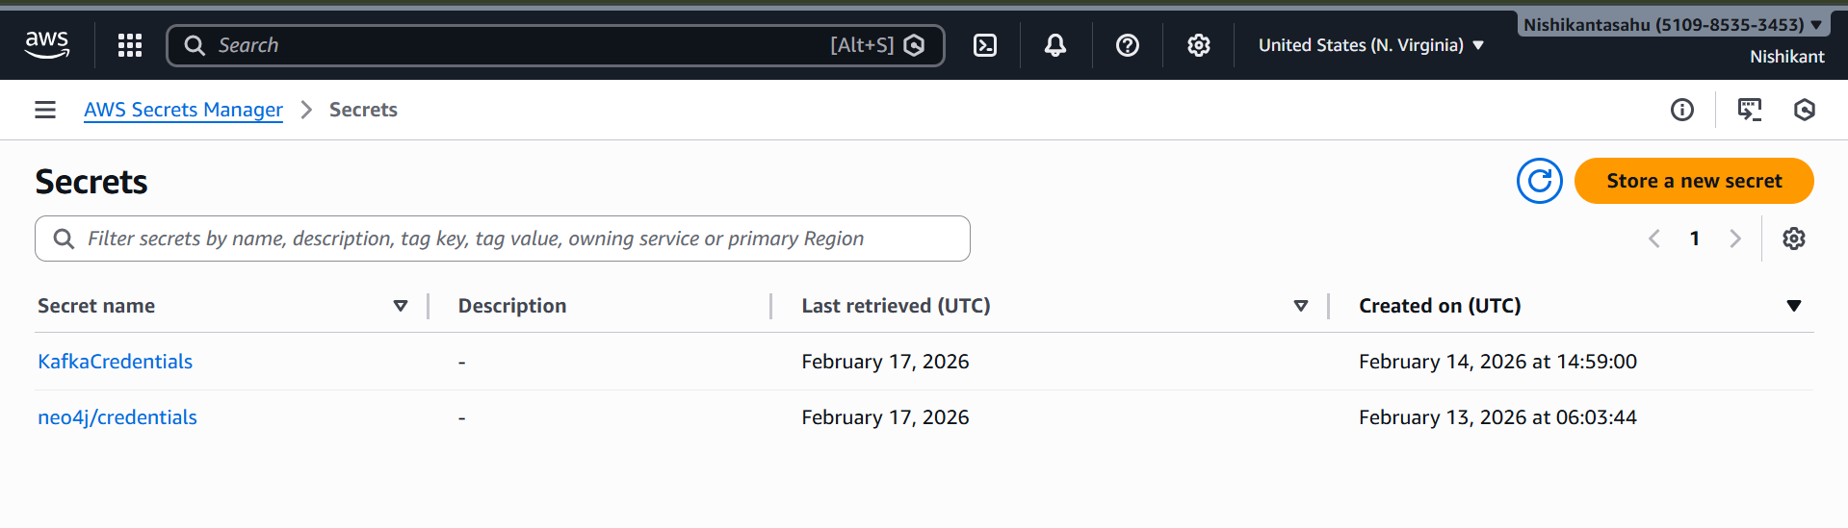
- Environment & Arguments
Streaming: .env for non-secrets (AWS region, bootstrap servers, topic), Secrets Manager for SASL and Neo4j.
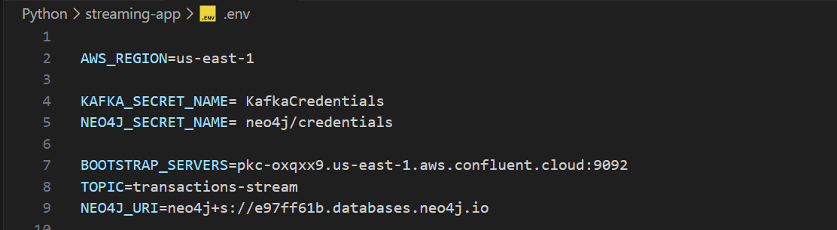
Batch (Glue): job arguments for S3_INPUT, S3_BAD_OUTPUT, NEO4J_URL, NEO4J_DB, NEO4J_SECRET_ARN, and RUN_VERIFY.
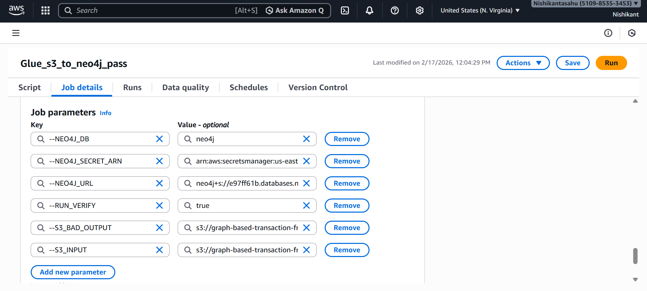

Security & Governance
- Credentials live in Secrets Manager; code reads them at runtime. No secrets in source.
- Provenance is preserved through file (batch) and Kafka metadata in bad-record envelopes (stream).
- Auditability via daily reconciliation artifacts, plus date/source-partitioned bad data.

Known Edge Cases & Handling
- Mixed header orders in CSV: Handled by per-file reads + union by name.
- Boolean variations of is_fraud: Normalized to 0/1; unrecognized values are flagged as mismatches.
- Timestamp anomalies: Rejected (stream) or routed to bad-records (batch) without crashing.
- Neo4j transient write conflicts: Reduced by fewer partitions and connector retry strategy.

Step-By-Step: How to Run

  - Batch (Glue)
- Stage files (CSV/JSONL/JSON) under your raw S3 prefix.
- Set Glue arguments: S3_INPUT, S3_BAD_OUTPUT, NEO4J_URL, NEO4J_DB, NEO4J_SECRET_ARN, RUN_VERIFY.
- Run job; review CloudWatch logs for sample payload and row counts.
- Check S3 bad records for mismatches/timestamp issues.
- Verify in Neo4j (Transaction nodes with source="batch").

  - Streaming
- Set secrets in AWS Secrets Manager (Kafka SASL, Neo4j user/pass).
- Configure .env with AWS_REGION, BOOTSTRAP_SERVERS, TOPIC, and secret names.
- Start consumer (recommended to start first). It will create bad-record folders if/when needed.
- Run producer with desired count and delay to simulate transactions.
- Verify in Neo4j (Transaction nodes with source="kafka").

